Solar Energy Exploration Kit
The Clean Energy Institute is working to speed the development of solar, battery and smart grid technologies in Washington State. Part of our effort is to support the teaching of clean energy topics in K-12 schools. The goals are to build positive attitudes about energy related STEM careers, to build skills that are essential to STEM, and to infuse the curriculum with knowledge about state of the art research advances through lab activities, demos and software. The SunDawg bag includes 2 small solar cars and lesson plans to elementary and middle school teachers. The Solar Energy Exploration Kit provides a class set of cars and includes additional supplies to support extended lessons. Please keep your kit components together in its cardboard storage box so that it can be used year after year. Contents
- 16 sets of SunDawg lesson cards
- 32 mini solar cars
- Color filter sampler
- 2 reflective card stock
- 1 electric multimeter
- 3 clip leads
- 2 solar 1.5volt panels (each panel has 3 cells wired in series)
- 1 DC motor
- 1 flashing LED
You will need
- A sunny day or
- 150W or higher incandescent spot light.
- Scissors, tape
- Copies of data sheets
Activities
- Mini Solar Cars Lessons Conduct the initial SunDawg activities, a solar car race, experimenting with solar angle, color filters, and car customization. Note: the inexpensive cars work well but they do easily lose their rubber tires which stop them from rolling. Check each tire to make sure it is on its wheel straight and not rubbing the car. The lesson work best if done in student pairs. You can download additional copies of the lesson plan cards and this solar energy exploration lesson with the link below.
http://www.cei.washington.edu/education/lessons/sun-dawg-solar-car-bags/

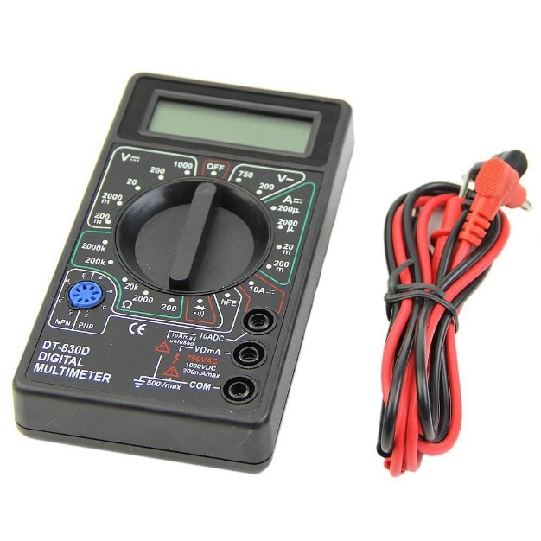
- Meter Measurement Assemble the multimeter. Place the red clip lead in the socket labeled Vma, and the black lead into the one label COM. Rotate the dial to DCV 20 (volts) or 2000m (millivolts) and measure the voltage across the leads of a solar cell under full illumination. Rotate the dial to dc amps 20m to measure the current in milliamps (1000th of an amp). Guide the students to make these observations or discoveries.
  - Solar cells produce positive voltage from one lead and negative from the other. If you look carefully you can see that the negative lead is coming from the top (light facing) side of the cell.
  - As you increase the amount of light the voltage increases up to a point (about .5 volts for a single cell or more if several cells are wire in series) and then no more.
  - The current continues to increase with additional illumination once you have reached the operating voltage for the cell.
  - The total power from the cell is calculated by multiplying volts x amps. P=V x A. Note: to calculate the power in watts the measured current in milliamps should be expressed in terms of amps. Eg 200m x .001 = .2 amps. See if you can confirm the manufacturer’s rating of .65 watts.
  - Connect the panels in series and measure the voltage and current. Repeat with the cells wired in parallel. Voltage is added in series, current is added in parallel.
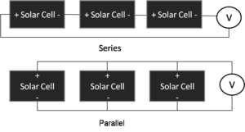
  - Measure the power from a panel as you tilt it with respect to the sun at 10 degree intervals. Plot angle vs power. Discuss the implications of this data for placing solar panels on a roof.

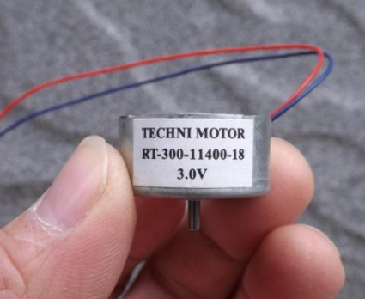
- Motor Spinner- Connect the DC motor to one or both solar cells. Place a gear or some kind of object on the shaft so that you can see it spinning.
  - What happens when you reverse the polarity of leads leading to the cell?
  - How does the speed of rotation relate to the power available from the panel(s)?
  - Can you design some kinetic art that spins when the sun shines?
  - If you were going to place this sculpture outside year round what engineering challenges would you have to solve?
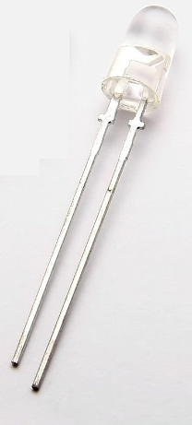
  - Can you design a car or boat that is powered by the solar cell and motor?

- LED Light- Connect the flashing Light Emitting Diode (LED) light to the solar cell. LED generally require about 3 volts so it will be necessary to connect both solar panels in series to get 3 volts. Also the LED needs to have its positive lead (the longer lead) connected to the positive (+) power source. The flashing LED has 3 colors of LEDs built into a single bulb and has a simple electronics inside that turns the three LEDS on and off in a cycle. Notice what how the speed and intensity of LED blinking changes when the power from the solar panel changes.

- Mini Solar concentrator Design a reflector that increases the amount of light reaching the solar cell. There are plans for a mini reflector that fits the solar car in the Sun Dawg lesson cards. Trace the pattern on the reflective poster board, cut it out with scissors and the tape the reflector together. An enlarged pattern that fits the 1.5 volt panels is provided below. Measure the power with and without the reflector in place. Measure the area of the opening and the area of the cell. How much increased power would you have predicted based on the ratio of opening to solar panel? Is there a limit to the amount of light you can collect with a front opening reflector.

- Parabolic reflector- Use Geogebra to reflector that focuses light to the panel. What is the ratio of magnification?
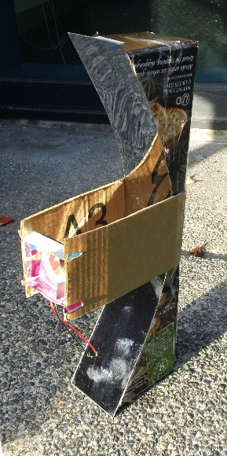
https://tube.geogebra.org/student/m812249 solar oven reflections https://tube.geogebra.org/student/m11884 spherical vs parabolic mirrors
http://tube.geogebra.org/material/show/id/1204549 segment mirror model
- Solar Tracker- Concentrating solar systems only work when the devise is facing the sun directly. Can you devise a support system that turns your concentrator gradually so that it faces the sun directly as the sun moves overhead?

- Temperature Effects. If you succeed in making a solar concentrator the solar cell may get quite warm in full sun. Use a thermometer to measure its temperature. Solar cells work better when they are cool because the thermal energy scatters the electrons as they diffuse towards output wires. Can you design an experiment that proves that solar cell performance decreases as the temperature increases? Hint: Heat the solar cell up, then let it cool down as you measure both the temperature and voltage under constant lighting. Plot voltage versus temperature.

- Shading Effects. Solar cells in a panel may at times be partially shaded. What do you predict is the effects? Design a set of experiments to find what direction and amount of shading causes the biggest impact on performance. When individual cells in a series arrangement are shaded they effectively become resistors pulling down the power of the whole string. This is not necessary proportional to the amount of cell that is shaded. A single cell will lose power proportional to the percentage of shading.

Sources for materials
Mini solar cars $2 at Amazon
http://www.amazon.com/MillionAccessories-Solar-Car-Smallest-Educational/dp/B004FEXUP4/ref=sr_1_1?ie=UTF8&qid=1430847610&sr=8-1&keywords=solar+mini+car
Mini solar car $1.42 from ebay
http://www.ebay.com/itm/New-Mini-Solar-Powered-Robot-Racing-Car-Vehicle-Educational-Gadget-Kids-Gift-Toy-/181782472922?hash=item2a531468da:g:H78AAOSwDNdViNbK

multimeter $4 at Amazon
http://www.amazon.com/Digital-Voltmeter-Ammeter-Multimeter-Dt830/dp/B00N3KQ4IG/ref=sr_1_113?ie=UTF8&qid=1446748758&sr=8-113&keywords=multimeter
Mirror Board - $10 at Amazon
http://www.amazon.com/Hygloss-Mirror-11-Inch-Silver-10-Pack/dp/B0044S5KFE/ref=sr_1_1?ie=UTF8&qid=1446748948&sr=8-1&keywords=mirror+board

Acrylic Mirror-polystyrene 2) 6”x 9” $4
http://www.amazon.com/Tim-Holtz-Idea-ology-Polystyrene-TH93029/dp/B009AG8XS6/ref=sr_1_1?s=home-garden&ie=UTF8&qid=1449767810&sr=1-1&keywords=adhesive+mirror

Color Filters- $14.99
http://www.amazon.com/gp/product/B003XX99V2/ref=oh_aui_detailpage_o00_s02?ie=UTF8&psc=1
DC Motor $1.49 Electronics Goldmine $1.49
http://www.goldmine-elec-products.com/prodinfo.asp?number=G18050

High Efficiency 300 Quiet Solar Panels Motor- ebay 10 for $16
http://www.ebay.com/itm/252066759206?_trksid=p2060353.m2749.l2649&ssPageName=STRK%3AMEBIDX%3AIT

Solar Panel 1.5 V, .65W from ebay- $3
http://www.ebay.com/itm/371433325541?_trksid=p2060353.m2749.l2649&ssPageName=STRK%3AMEBIDX%3AIT
Exploration with Solar Cells- Data Sheet
Name (s) ___________________________________________
Perform some experiments with the cells and panels provided. Try different light sources, combinations in series and parallel, running a motor or car. Measure the output in volts and milliamps.
Solar Cells Used | Conditions | voltage | amperage

Conclusions – Based on your experiments what rules can you state about solar cells and circuits:

Exploration with Solar Cells and Angles of Incidence- Data Sheet
Name (s) ___________________________________________
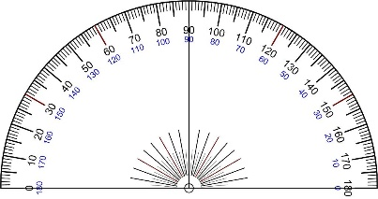
Rotate the solar cell to different angles with respect to the sun, or move a focused light source, measured with a protractor. Measure the output in volts and milliamps. If the lowest angle is reading full voltage you may just record amperage as this is an indicator of the changing power of the cell.
60 deg
90 deg
0 deg

Angle degrees | Voltage V | Amperage (ma) | Power
0
10
20
30
40
50
60
70
80
90

Conclusions –
- Based on your experiments what rules can you state about solar cells and angle of incidence:

- If you arranged solar panels to capture low angle light what happens when they get close to each other? How would this affect the layout of your solar farm?

- Copy and cut out outline of the reflector
- Trace outline on the back of the reflective material- or cardboard lined with aluminum foil
- Cut out the shape in the reflective material
- Use a straight edge to fold at lines marked *
- Join Edge A to Edge B with tape
- Place the reflector around the solar cell and secure with tape
VE
R
TI
C
AL
REFLE
C
T
OR
E
dge A
E
dge B

